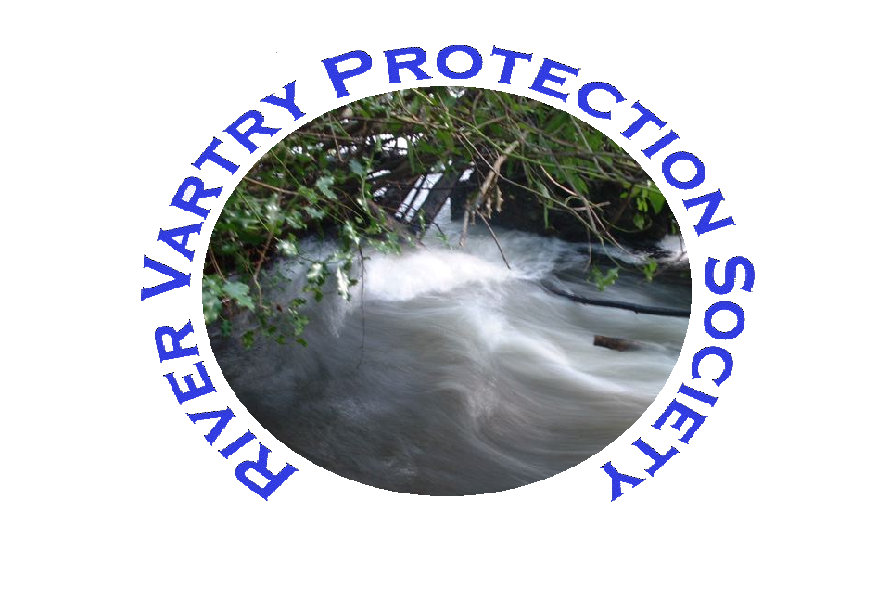
River Vartry Protection Society
Nun’s Cross
Ashford
Co. Wicklow

Re: Planning Application 09/0500
We are the River Vartry Protection Society and would like to object to application 09/050 - Michael Ryan Clora, Nun’s Cross Ashford.
The planned development has two subjects which cause our members major concerns.
- Damage to the Nun’s Cross Bridge
- Pollution and Damage to the Salmon and the River

The Proposed Surface Water Plan show Drilling and inserting over 9 meters of piping to the structure of the Nun’s Cross Bridge. This is a protected structure and important to the environment of the River as one of the oldest bridges along the river. Such work will, without doubt damage the bridge and the oldest of the Arches dating from the 1700’s and on a 1730 map in our possession. Permission can not be granted on a project that does not have a viable solution for Surface Water.

Even if there were a solution as to how to access the River, we feel that it breaking EU law to allow this kind of discharge into an EU Protected River. This is compounded in that the location is just above the River’s most important Salmon beds. We are aware that the Eastern Region Fisheries Board have been clearing trees and plan to refurbish the basin with gravel in the coming months just below the bridge. All this good work would be compromised with runoff pollution from paving and from the houses in the estate. An Bord Pleanála have already objected to this in their decision on the appeal PL 27.226086 with concerns about potential pollution. We believe that the damage to the River outlined in this planning application would be irreversible. We as you to please unconditionally refuse permission on this Development.

Wednesday, 13 May 2009
Secretary for the River Vartry Protection Society

